# CCET 3680 Master CAM setting the environment

I. Setting up Layers:

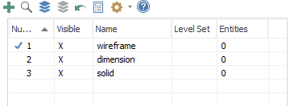

II. Setting up grid:

